**Crimson Global Academy Report**

From website online academy is geared towards students who are:

* Academically ambitious (we want smart kids)
* Athletes and Performers (due to their demanding schedules)
* Travelling students (for families who move frequently)

My ideas –

* Disability – Potentially beneficial to advertise in areas with schools for special needs children. (Provides more options to parents.)
* Parents with younger children in higher ICSEA percentile. (primary schools)
  + Rich parents who may want more time with their children.
  + Age range – 8-18
* Rural areas with high ICSEA
* Regions with a High Percentage of Non-English Speaking Backgrounds
* Schools with High Proportions of Academically Ambitious Students
  + schools with a high percentage of students in the Top SEA Quarter (%)
* Schools with higher full-time equivalent enrolments indicate areas with a stable student population, making them reliable targets for sustained advertising efforts.

Goal –

* Develop a scatter plot representing the change of student population over the years
* This will have to be based off school name and suburb

Progress –

So far, I have extracted the percentage change of enrollments within schools over a time period from 2020 to now. I have also calculated the avg change of enrollment percentage revealing the average change in population of a school. Although data is not taken from a longer period of time, leaving the results inaccurate this is the safest method to find a consistent change in enrollment history of schools.

By displaying the Avg_Percentage_Change of each school in descending order we get the schools listed at the top with the highest or most dramatic increase in enrollment size since 2020. This result shows a trend revealing which schools are growing the fastest. This could potentially be an indication of population increase in certain areas.

Complications –

The problem is visualizing this result.

When calculating average percentage change from 2020 to present day, there is no previous enrollment history data available for the first year 2020. This means that the averages are incorrectly calculated as they are considering an extra 0 term. We must remove the 2020 total enrollments rows to correctly calculate change in percentage.

The problem was arising because I was setting null values to 0. Specifically for rows where year was 2020, there was no previous enrolment data for 2019 since we are considering data from 2020 onwards. This meant that 0 was being considered as a value in the average when it should be dismissed. When keeping the values set to null, sql ignores this values and uses only 3 from 2021,2022,2023 to calculate average change. Now we have a more accurate avg percentage change in enrollment count of schools.

***Hypothesis:***

Areas that may have a high ICSEA may also have a lower percentage change in enrollments over time. This may be because suburbs with high ICSEA may be more stable in terms of population size than suburbs with lower ICSEA. This might mean that enrollments for these areas may not change much over time. Parents tend to be comfortable with their kids’ enrollments so advertising here may not be ideal.

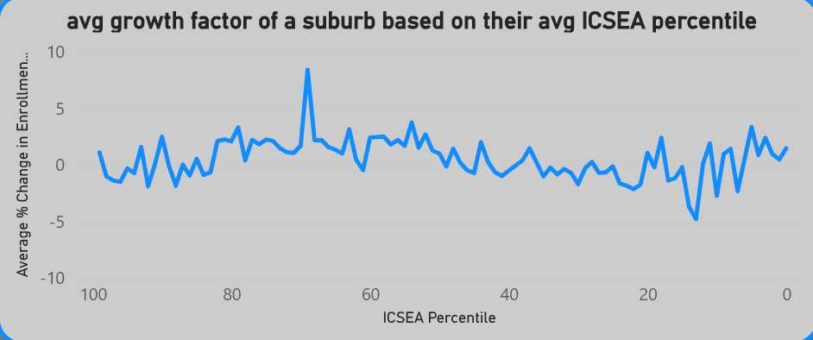

By looking at suburbs by their average ICSEA percentile we can distinguish which suburbs tend to have the schools with the highest ICSEA percentile. This can help us figure out if the ICSEA percentile of a suburb has any affect on the avg percentage change of enrollments within them. From the data above it is clear that regardless of the ICSEA percentile of a suburb, the avg percentage change of population is not affected.

The data above models the avg change in enrollment numbers based off of the average ICSEA percentile of schools in a suburb. This forms an avg ICSEA percentile for each suburb and then models the change in enrollments since 2020. From the data it is clear that ICSEA percentile of a suburb does not have a correlation with its growth in enrolments. The change in enrollments over the years based on ICSEA percentile tend to remain consistent regardless of the ICSEA percentile. From this we can conclude that This data will be irrelevant in figuring out which areas are most ideal to advertise.

***Hypothesis:***

Private schools with higher ICSEA percentiles will tend to be expensive and so as a result will have richer students. We can find private schools with the highest ICSEA percentiles and advertise there.

Top sea quarter % represents the number of students at school which are from the highest socio-educational advantage. So schools with higher Top sea Quarter % will tend to have more students in the top 25% of Australia in terms of social educational advantage.